CONFIGURING DNS USING BIND Centos
Setting up DNS server
DNS (Domain Name Server) need to resolve the domain names and hostnames into IP address.

6.1 DNS terminology

zone | The domain name space is divided into regions
DNS server | A server that maintains the name and IP information for a domain  - A primary DNS server for master zone  - A secondary server for slave zone or slave server without any zones for caching
Master zone DNS server | Includes all hosts from network and DNS server master zone stores up-to-date records for all the hosts in the domain
Slave domain DNS server | Copy of the master zone and obtain its zone data with zone transfer operations from its master server. It responds authoritatively for the zone if valid zone.  It is just a backup servers which is used to copy the same zone information’s from the master servers.
Forwarder | DNS server should send queries it cannot answer
DNS Record  - A record  - NS (name server) record  - MX (mail exchanger) record  - CN (canonical name) record  - PTR (Pointer) record  - SOA (Start of Authority) record | Information about name and IP address.  - is used to map hostname to an IP address  - identifies authoritative DNS server for the zone  - specifies a mail server responsible for accepting of mail in the zone  - specifies alias of one name to another name  - are reverse DNS record i.e. from IP address to hostname  - contains information about that DNS zones & other DNS records.

Setup the DNS server with below requirements:
a. IP address: 192.168.8.11/24
b. Domain name: gmi.net
c. Hostname: jimi

1. Log in as root and type the following command to see the current hostname:
hostnamectl status
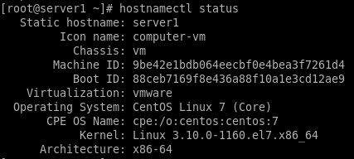

2. Change the hostname value according to the requirement above.
hostnamectl set-hostname jimi
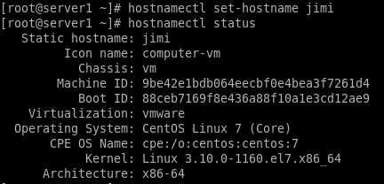

3. Install DNS BIND
(make sure that you are connecting to Internet – choose NAT)
yum install -y bind bind-utils
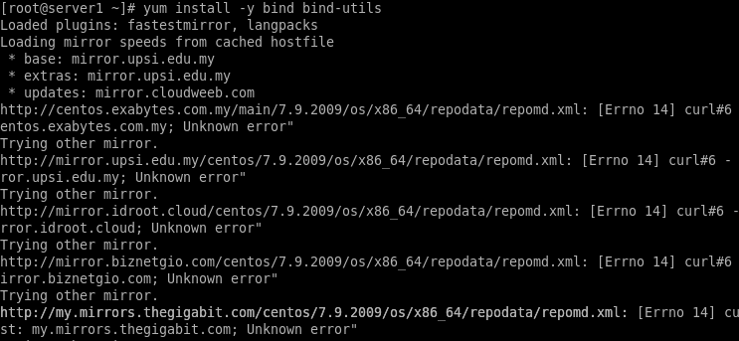
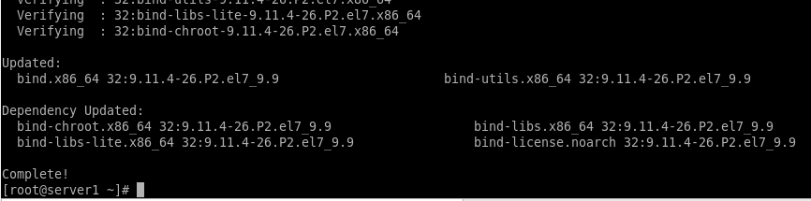
** Troubleshoot
When you try to update using ‘yum update’, sometimes it will not update and give an error, try Then type below command in the terminal and then update the CentOS
dhclient

4. Setup static IP address ( and choose Local Host/ Internal network – to disconnect from Internet)
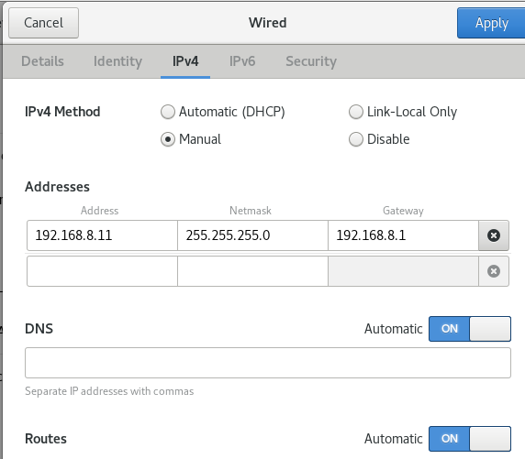

5. To back up the original named.conf file
cp /etc/named.conf /etc/named.conf.orig

6. Edit main configuration file
vim /etc/named.conf
Edit:
listen-on port 53 { 127.0.0.1;192.168.8.11; }; # Configure BIND to listen to a particular IP address, put server static IP address
allow-query { localhost;192.168.8.0/24; }; # This setting will allow clients from the mentioned network can query the DNS for the name to ip translation, put 192.168.8.0/24
recursion no ; # since we are configuring an authoritative-only server, we will disable contacting other remote DNS servers, find the line that reads recursion yes; and change it to no.
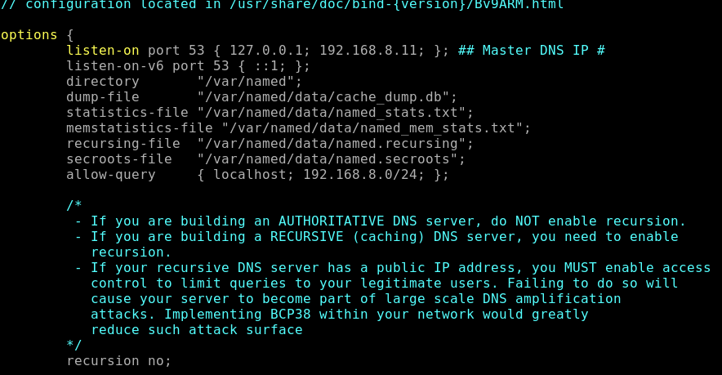
After changes had been made, save and exit from the configuration file (:wq)

7. Start DNS services
systemctl start named
systemctl enable named
systemctl status named

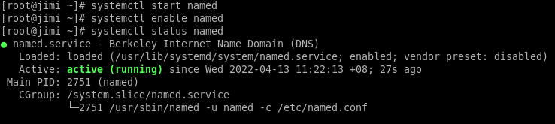
Note: If any error appears after any of this command, then check again the main configuration file (named.conf). After make any changes, start DNS services.
systemctl start named
systemctl enable named
systemctl status named

8. Add a allow rule in the firewall to let clients can connect to the DNS server for name resolution.
firewall-cmd --permanent --add-port=53/tcp
firewall-cmd --permanent --add-port=53/udp
firewall-cmd --reload
firewall-cmd --list-all

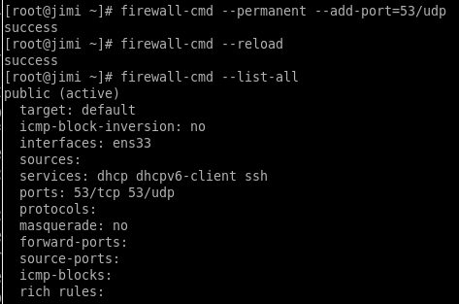
9. Creating the Forward and Reverse DNS Zones
A Forward Zone is where the hostname (or FQDN) to IP address relations is stored; it returns an IP address using the hostname. Note that normal DNS queries are forward lookup queries. On the other hand, a Reverse Zone returns the FQDN of a host based on its IP address.

vim /etc/named.conf
Create forward and reverse zone as below:
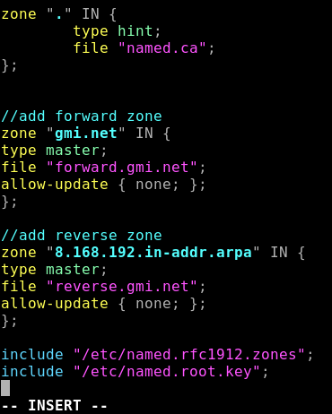
Forward zone definition:
‘gmi.net’ is the Domain name
‘master’ is the Primary DNS
‘forward.gmi.net’ is the Forward lookup file
‘allow-update’ will be none, it’s the primary DNS

Reverse zone definition:
‘gmi.net’ is the Domain name
‘master’ is the Primary DNS
‘reverse.gmi.net’ is the Reverse lookup file
‘allow-update’ will be none, it’s the primary DNS

After changes had been made, save and exit from the configuration file (:wq).
Start DNS services
systemctl start named
systemctl enable named
systemctl status named

10. Creating Forward DNS Zone File
a. Create a zone file called forward.gmi.net for forward lookup under /var/named directory.
b. Copy named.localhost to forward.gmi.net
c. Edit the configuration file.

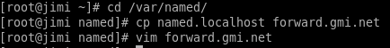
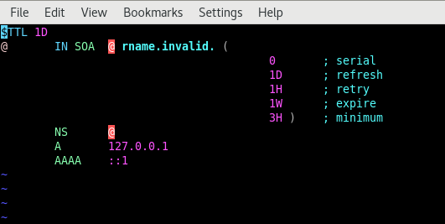
d. Delete the above lines, and replace with the following lines:
Notes: Please use tab key, instead of using the spacing bar.
Do not forget the . dot at the end of domain name.

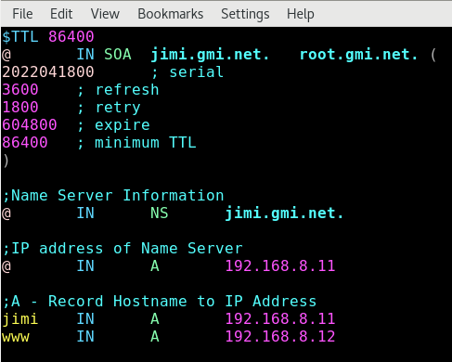

11. Creating Reverse DNS Zone File
a. Create a zone file called reverse.gmi.net for reverse lookup under /var/named directory.
b. Copy template from forwards.gmi.net to reverse.gmi.net

c. Edit the following configuration in it. Here, the PTR is the opposite of A record used to map an IP address to a hostname.
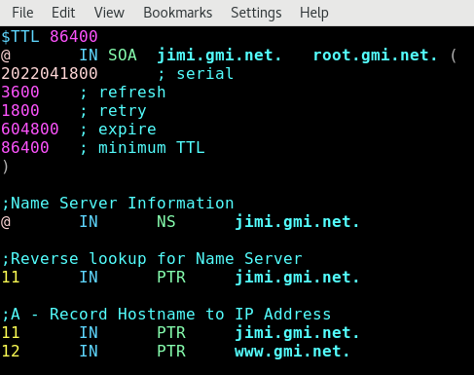

12. Set the correct ownership permissions on the zone files as follows.
Before modification:
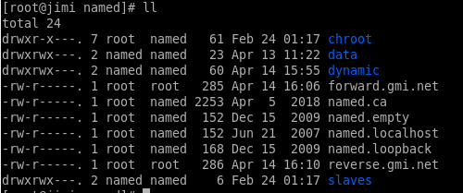
After modification:
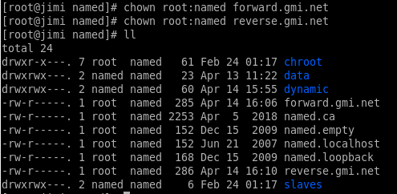
**only look for forward.gmi.net and reverse.gmi.net
13. Finally, check the DNS configuration and the zone files has the correct syntax after making the above changes, using the named-checkconf utility. If it returns nothing, the configuration file is valid. If error occurred, double check the zone files.
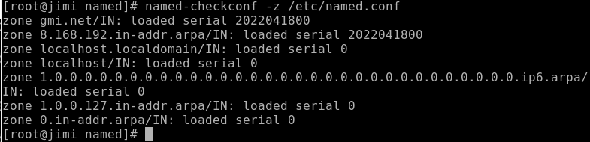
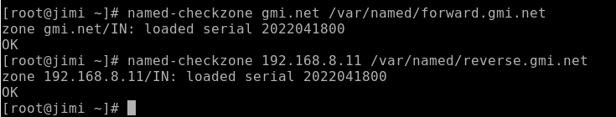
14. Once you have performed all the necessary configuration, you need to restart the DNS service for the recent changes to take effect.
systemctl restart named

15. Add the DNS Server details in your network interface config file.
vim /etc/sysconfig/network-scripts/ifcfg-ens33 (should follow your own network profile, as below show is enp0s3)
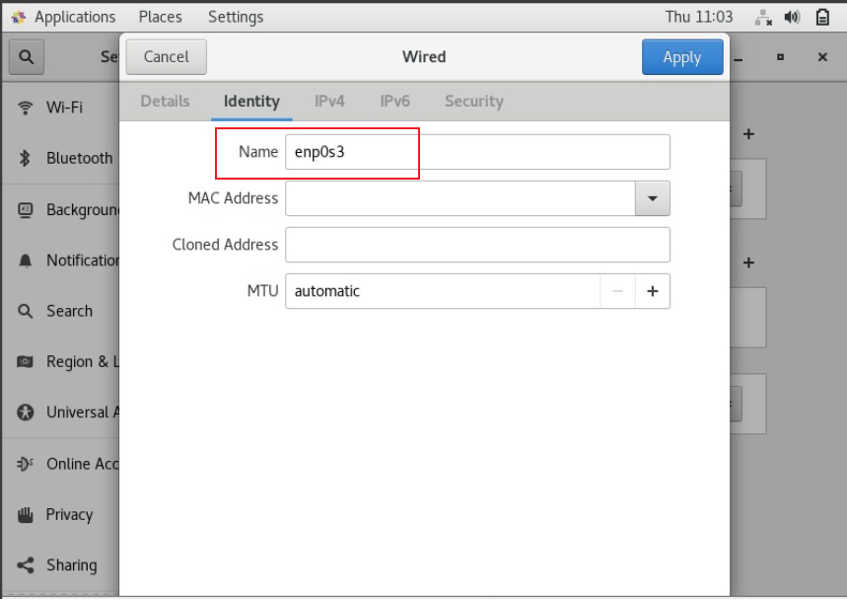
DNS Details :
IPADDR, PREFIX, GATEWAY and DNS (these details should display as below)
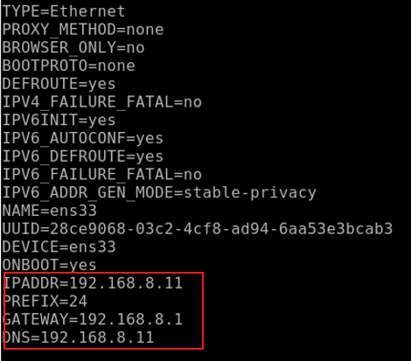

16. Add the nameserver ip address in /etc/resolv.conf
vim /etc/resolv.conf
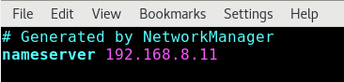
Save and close the file.

17. Restart network service
systemctl restart network
p/s: If there is an error, double check the network properties. Please ensure that the IP address is static.

TEST DNS SERVER
18. In this example, the status is NOERROR, which means that the requested authority served the query without any issue.
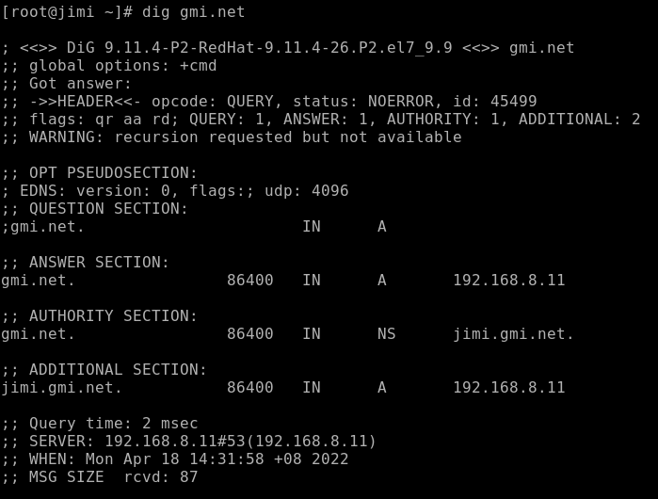
19. Checking DNS
The nslookup tool is used to view name to IP address or IP address to name resolution. So, issue the nslookup command to view whether your configured DNS Server can resolve DNS request or not.
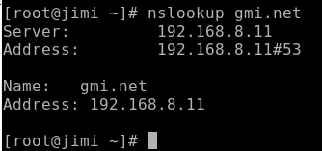
If your output is like the above output, DNS server able to resolve name to IP address.

20. Issue the following command to view IP address to name resolution. If you get the below output, DNS server is also capable to resolve IP address to name.
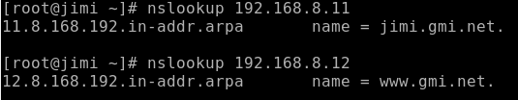
TROUBLESHOTING NOTES:
*** Whenever the main configuration (named.conf) had changed, you need to restart the dns service.
systemctl restart named
systemctl enable named
systemctl status named
CLIENT SIDE CONFIGURATION ( at Server2)
In this section, we will show how to test the DNS service from a client side. Log into the client machine, configure it to use the above DNS server.
1. Open the file /etc/resolv.conf.
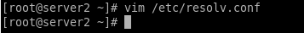

2. Edit the file. Enter the server’s domain and IP address. Save and close the configuration after modification has been made.
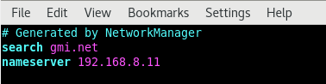
3. Open and edit network setting.
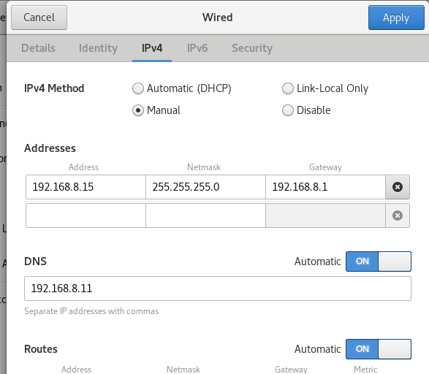

4. After changes has been made, restart the network manager to take effect.
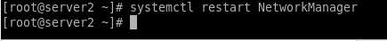
5. Time to test the DNS server.
a.
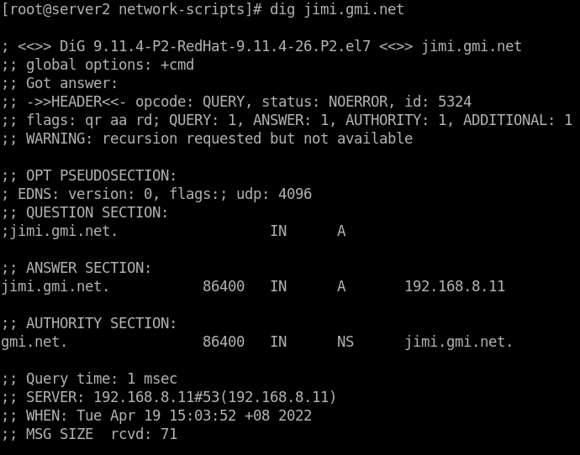
b.
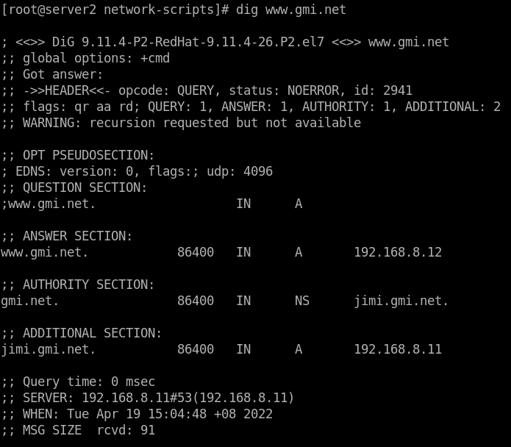
c.
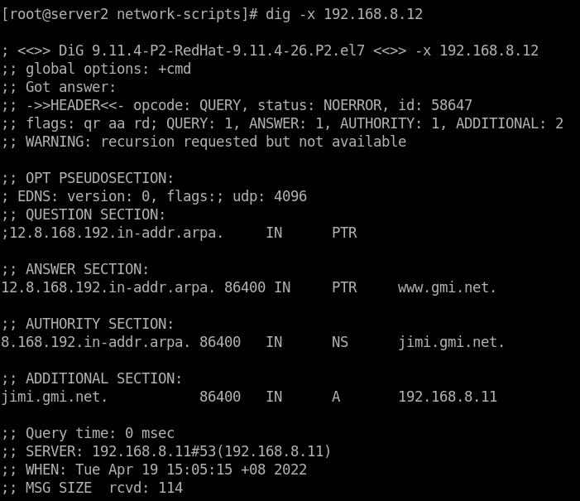

d. nslookup
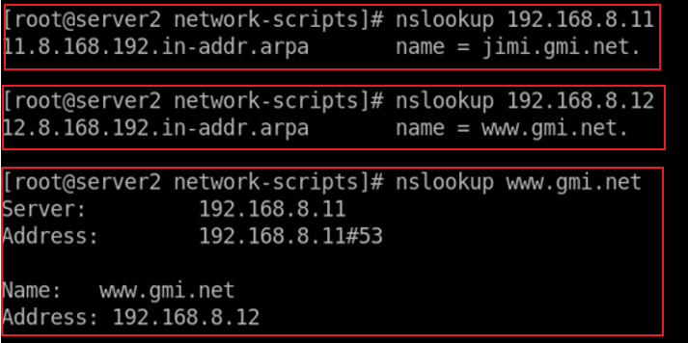
nslookup jimi.gmi.net

References:
https://www.youtube.com/watch?v=is-eg2X5ru4
https://www.youtube.com/watch?v=7y_8BvjmYcY
https://linuxtechlab.com/configuring-dns-server-using-bind/
https://www.tecmint.com/install-bind-private-dns-server-on-rhel-8/

